Applied Mathematics

🌟 Definition
# Source: AI Source: Provided by: [Data Path: Persons Table -> ID Column: 1, Name_En Column: Motasem Essam] -> From: [ChatGPT] on [5/30/2026]
Applied Mathematics is the branch of mathematics that uses mathematical concepts, theories, models, and techniques to solve real-world problems in science, engineering, technology, business, economics, medicine, and many other fields.
It focuses on applying mathematical knowledge to understand, describe, predict, and optimize real systems and phenomena.

🎯 Purpose of Applied Mathematics
# Source: AI Source: Provided by: [Data Path: Persons Table -> ID Column: 1, Name_En Column: Motasem Essam] -> From: [ChatGPT] on [5/30/2026]
- To solve practical problems
- To model real-world systems
- To predict future outcomes
- To support scientific research
- To improve engineering and technology
- To assist decision-making and optimization

📚 Main Branches of Applied Mathematics

1. Statistics
# Source: AI Source: Provided by: [Data Path: Persons Table -> ID Column: 1, Name_En Column: Motasem Essam] -> From: [ChatGPT] on [5/30/2026]
Studies the collection, analysis, interpretation, and presentation of data.
Topics
- Descriptive Statistics
- Inferential Statistics
- Regression Analysis
- Statistical Testing
Example Question
- What can survey data tell us about a population?

2. Probability Theory
# Source: AI Source: Provided by: [Data Path: Persons Table -> ID Column: 1, Name_En Column: Motasem Essam] -> From: [ChatGPT] on [5/30/2026]
Studies uncertainty, randomness, and chance.
Topics
- Random Variables
- Probability Distributions
- Stochastic Processes
- Risk Analysis
Example Question
- What is the probability of rain tomorrow?

3. Mathematical Modeling
# Source: AI Source: Provided by: [Data Path: Persons Table -> ID Column: 1, Name_En Column: Motasem Essam] -> From: [ChatGPT] on [5/30/2026]
Creates mathematical representations of real-world systems.
Topics
- Population Models
- Economic Models
- Climate Models
- Biological Models
Example
A population growth model:
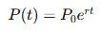
$$P(t)=P_{0}e^{rt}$$

4. Engineering Mathematics
# Source: AI Source: Provided by: [Data Path: Persons Table -> ID Column: 1, Name_En Column: Motasem Essam] -> From: [ChatGPT] on [5/30/2026]
Applies mathematics to engineering design and analysis.
Topics
- Differential Equations
- Numerical Methods
- Control Systems
- Signal Processing
Example Formula
$$F=ma$$

5. Computational Mathematics
# Source: AI Source: Provided by: [Data Path: Persons Table -> ID Column: 1, Name_En Column: Motasem Essam] -> From: [ChatGPT] on [5/30/2026]
Uses computers and numerical methods to solve mathematical problems.
Topics
- Numerical Analysis
- Scientific Computing
- Simulation
- Optimization Algorithms
Example Question
- How can a computer approximate a solution that cannot be solved exactly?

6. Operations Research
# Source: AI Source: Provided by: [Data Path: Persons Table -> ID Column: 1, Name_En Column: Motasem Essam] -> From: [ChatGPT] on [5/30/2026]
Studies optimization and decision-making.
Topics
- Linear Programming
- Network Optimization
- Scheduling
- Resource Allocation
Example Question
- What is the most efficient delivery route?

7. Financial Mathematics
# Source: AI Source: Provided by: [Data Path: Persons Table -> ID Column: 1, Name_En Column: Motasem Essam] -> From: [ChatGPT] on [5/30/2026]
Applies mathematics to finance and economics.
Topics
- Interest Models
- Investment Analysis
- Risk Management
- Derivative Pricing
Example Formula
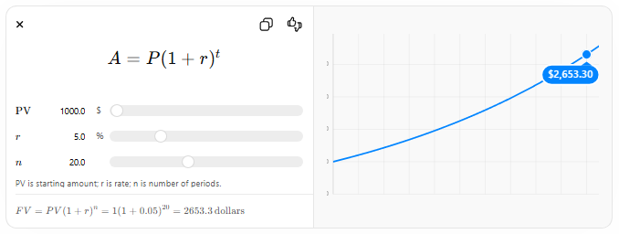
$$A=P(1+r)^{t}$$
$$PV$$
$
$$r$$
%
$$n$$
PV is starting amount; r is rate; n is number of periods.
$$FV=PV(1+r)^{n}=1(1+0.05)^{20}=2653.3\text{ dollars}$$

🧩 What Applied Mathematics Studies
# Source: AI Source: Provided by: [Data Path: Persons Table -> ID Column: 1, Name_En Column: Motasem Essam] -> From: [ChatGPT] on [5/30/2026]
Applied mathematics studies:
- Physical systems
- Engineering problems
- Economic systems
- Financial markets
- Computer algorithms
- Biological processes
- Medical data
- Environmental systems
- Technological applications

🔗 Relationship to Other Mathematical Fields
# Source: AI Source: Provided by: [Data Path: Persons Table -> ID Column: 1, Name_En Column: Motasem Essam] -> From: [ChatGPT] on [5/30/2026]
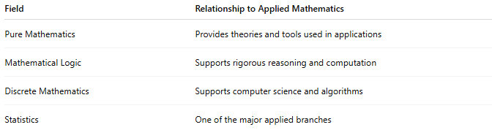
Field | Relationship to Applied Mathematics
Pure Mathematics | Provides theories and tools used in applications
Mathematical Logic | Supports rigorous reasoning and computation
Discrete Mathematics | Supports computer science and algorithms
Statistics | One of the major applied branches

✏️ Example Questions
# Source: AI Source: Provided by: [Data Path: Persons Table -> ID Column: 1, Name_En Column: Motasem Essam] -> From: [ChatGPT] on [5/30/2026]
- How can mathematics predict weather changes?
- What is the safest design for a bridge?
- How can disease spread be modeled?
- What investment strategy minimizes risk?
- How can traffic flow be optimized?

📖 Applied Mathematics vs Pure Mathematics
# Source: AI Source: Provided by: [Data Path: Persons Table -> ID Column: 1, Name_En Column: Motasem Essam] -> From: [ChatGPT] on [5/30/2026]
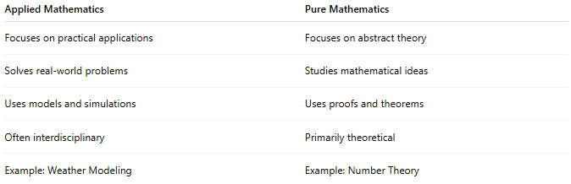
Applied Mathematics | Pure Mathematics
Focuses on practical applications | Focuses on abstract theory
Solves real-world problems | Studies mathematical ideas
Uses models and simulations | Uses proofs and theorems
Often interdisciplinary | Primarily theoretical
Example: Weather Modeling | Example: Number Theory

🧠 Simple Analogy
# Source: AI Source: Provided by: [Data Path: Persons Table -> ID Column: 1, Name_En Column: Motasem Essam] -> From: [ChatGPT] on [5/30/2026]
Applied mathematics is like using mathematical tools to solve real-life challenges:
- Pure mathematics creates the tools.
- Applied mathematics uses the tools.
For example:
- Pure mathematics develops calculus.
- Applied mathematics uses calculus to design aircraft, predict weather, and model disease spread.

🧭 Summary
# Source: AI Source: Provided by: [Data Path: Persons Table -> ID Column: 1, Name_En Column: Motasem Essam] -> From: [ChatGPT] on [5/30/2026]
Applied Mathematics is the branch of mathematics that applies mathematical theories, methods, and models to solve practical problems in science, engineering, business, medicine, technology, and everyday life. It connects mathematical knowledge with real-world applications.

